DR. AMBEDKAR COLLEGE, DEEKSHABHOOMI, NAGPUR,

DEPARTMENT OF LAW
ACADEMIC SESSION 2021-22
NAME OF PROGRAMME: | Guest lecture on the topic “E-Consumerism- Rights and Responsibilities of Consumers in E- Commerce”
DATE AND DAY: | 22nd November 2021
TIME: | 11. 00 AM
VENUE: | Virtual
GOOGLE MEETING LINKS: | https://meet.google.com/gcy-hsia-cgu
PROGRAMME SUPERVISOR: | Mrs. Vaishali A. Sukhdeve

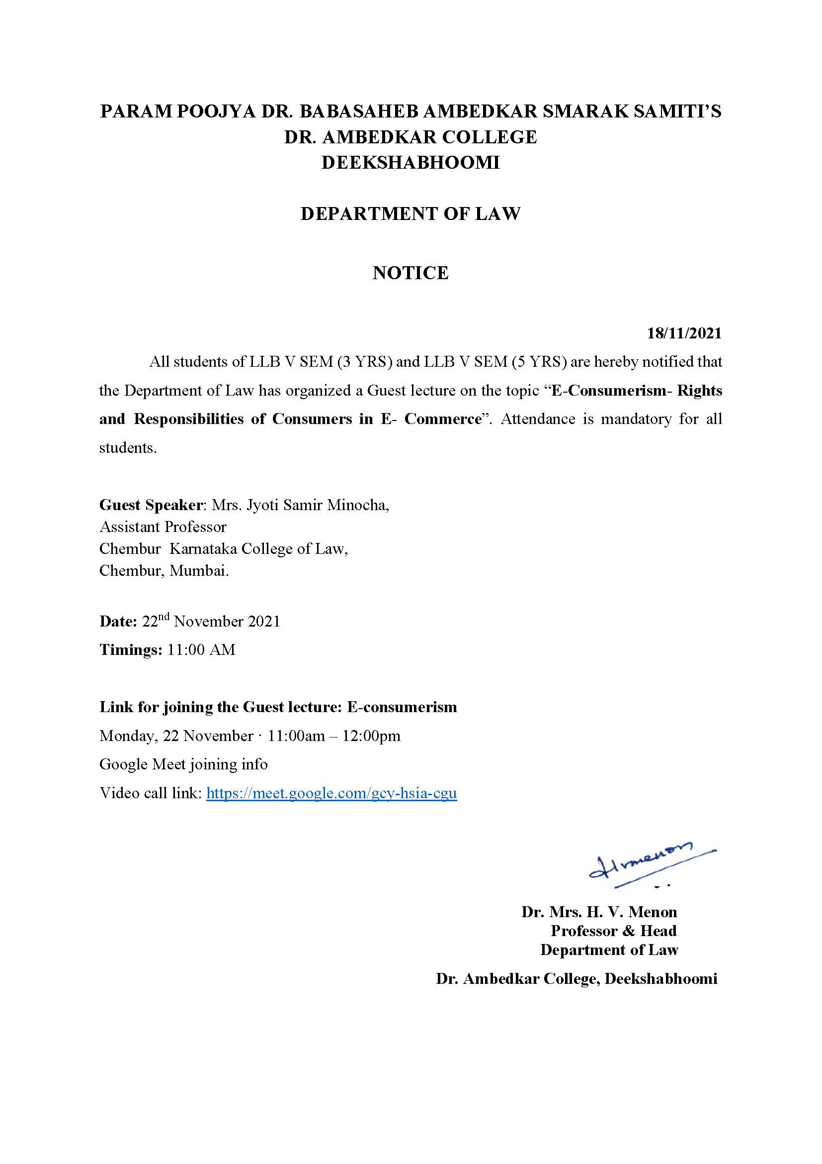
Department of Law of Dr. Ambedkar College, Deekshabhoomi, Nagpur conducted a Guest lecture on the topic “E-Consumerism- Rights and Responsibilities of Consumers in E- Commerce” for the students of V Semester BA. LLB 5 Years and LLB 3 Years course. Total 60 students attended the guest lecture through Google meet link at 11.00 AM.
Mrs. Jyoti Samir Minocha, Assistant Professor in Chembur, Karnataka College of Law, Mumbai was invited as a guest speaker to deliver lecture on the topic E-Consumerism- Rights and Responsibilities of Consumers in E- Commerce. Mrs. Minocha started the session with the historical background of Consumer movement in India. She further highlighted how the definition of consumer is applicable to the concept of E-commerce in contemporary times. She gave a comparative analysis of the provisions of Consumer Protection Act of 1986 and 2019. She discussed all the new provisions inserted in the new Act of 2019 laying emphasis on Mediation technique as one of the effective modes of Consumer dispute resolution. Use of E- commerce by the consumers by shopping from different online websites led to the issues involved with respect to the rights of the buyers on one hand and the responsibilities of the consumers as well as the sellers on other hand. She also focused on how the online sellers and to what extent the Online service providers could be held responsible. This is an emerging problem which requires different approaches and some efficient regulating authorities. The new Act of 2019 dealt with this issue which was critically analysed and explained by the guest speaker.
Mrs. Jyoti Minocha further highlighted the procedures for making online complaints and in this she also discussed the jurisdictions of different forums starting from District Consumer Redressal forum now known as District Commission as per the New Act of 2019. The pecuniary and territorial jurisdictions of State Commission and National Commission has seen amendments in the New Act which was explained in detail.
This was followed by the question answer session. All the questions related to practical applicability of the Act and the problems involved in online shopping were answered in detail by the Guest Speaker, Mrs. Jyoti Minocha to the satisfaction of the students. The program was conducted and co-ordinated by Mrs. Vaishali A. Sukhdeve under the able guidance of Head of the Department, Prof. Dr. Mrs. H.V. Menon.

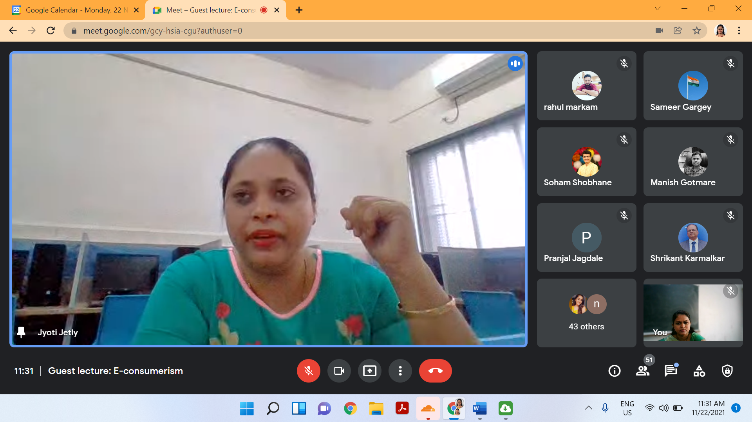
Guest speaker Mrs. Jyoti S. Minocha addressing the students about the rights of the consumers in E-Commerce.

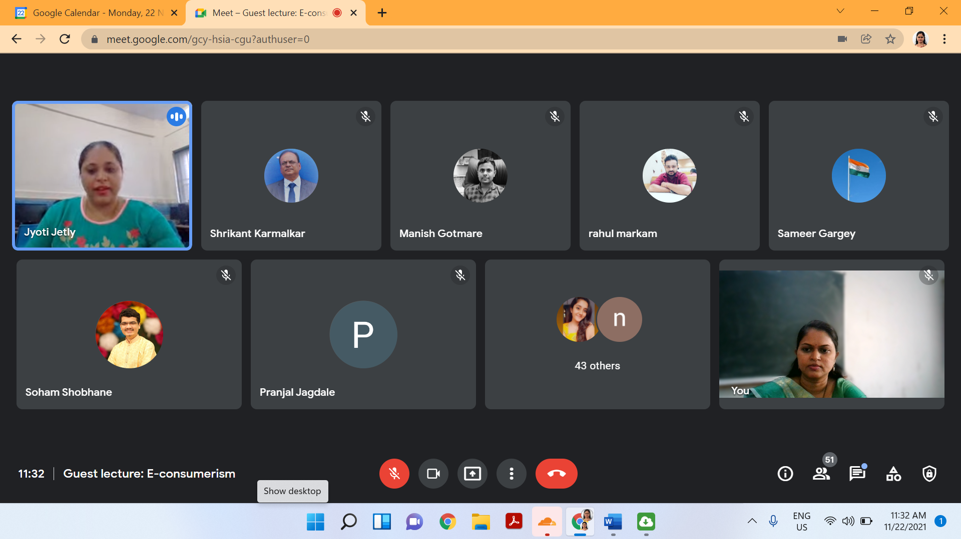
Guest speaker answering the questions posed by the students with respect to responsibilities of the Online sellers.

